Auriana Anderson
Jeremiah Lowhorn
Assignment 3
2/2/2025
Assignment 3
Complete the following Textbook Exercises 6.7, 6.8, 6.10, 6.12, 6.13.
6.7
exercise_67-1.sqlDownload exercise_67-1.sql
Consider the following Hotel, Room, Booking and Guest schemas in a DBMS. The hotelNo is the primary key for Hotel table and roomNo is the primary key for the Room relation. Booking stores the details of room reservations and bookingNo is the primary key. Guest stores the guests details and guestNo is the primary key.
Hotel (hotelNo, hotelName, hotelType, hotelAddress, hotelCity, numRoom)
Room (roomNo, hotelNo, roomPrice)
Booking (bookingNo, hotelNo, guestNo, checkIn, checkout, totelGuest, roomNo)
Guest (guestNo, firstName, lastName, guestAddress)
- Write the SQL to list full details of all the hotels.
  - SELECTS a.*
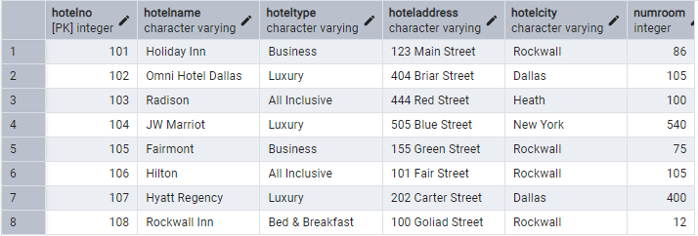
FROM hotels."hotel" a;

- Write the SQL to list full details of all the hotels in New York.
SELECT a.*
FROM hotels."hotel" a
WHERE a."hotelcity" = 'New York';

- Write the SQL to list the guests in New York in descending order by last name.

Please use the exercise_67.sql DDL to complete this exercise. You will need to write a join between booking, hotels, and guests. Your book specifies how to do on page 222, however, this does not work in PostgreSQL. Below is the format you will need to use, please replace all <> to answer the question. Please submit the query and the query results.
SELECT c.*
FROM hotels."booking" a
JOIN hotels."hotel" b
ON a."hotelno" = b."hotelno"
JOIN hotels."guest" c
ON a."guestno" = c."guestno"
WHERE b."hotelcity" = 'New York'
ORDER BY c."lastname" desc;

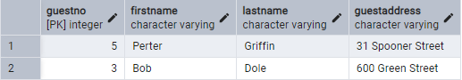

6.8
Write appropriate SQL DDL statements for declaring the LIBRARY relational database schema of Figure 6.6. Specify the keys and referential triggered actions.
Write the schema create statement along with the relation create statements. You may insert data, but this is optional. Please submit your SQL DDL (schema & tables).

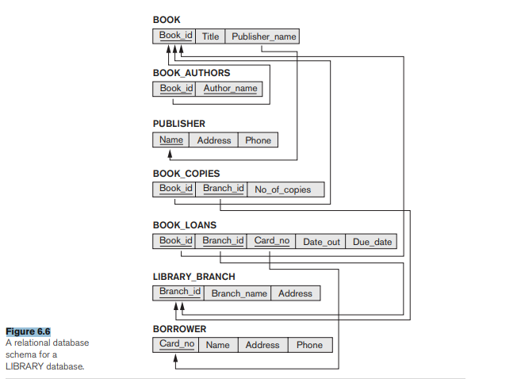

CREATE SCHEMA IF NOT EXISTS library;

CREATE TABLE IF NOT EXISTS library.publisher (
Name VARCHAR(255) PRIMARY KEY,
Address VARCHAR(255),
Phone VARCHAR(20)
);

CREATE TABLE IF NOT EXISTS library.book (
Book_id INT PRIMARY KEY,
Title VARCHAR(255) NOT NULL,
Publisher_name VARCHAR(255) NOT NULL,
FOREIGN KEY (Publisher_name) REFERENCES library.publisher (Name) ON DELETE SET NULL
);

CREATE TABLE IF NOT EXISTS library.book_authors (
Author_name VARCHAR(255) NOT NULL,
Book_id INT,
PRIMARY KEY (Book_id, Author_name),
FOREIGN KEY (Book_id) REFERENCES library.book(Book_id) ON DELETE CASCADE
);

CREATE TABLE IF NOT EXISTS library.library_branch (
Branch_id INT PRIMARY KEY,
Branch_name VARCHAR(255) NOT NULL,
Address VARCHAR(255) NOT NULL
);

CREATE TABLE IF NOT EXISTS library.book_copies (
Book_id INT,
Branch_id INT ,
No_of_copies INT NOT NULL,
PRIMARY KEY (Book_id, Branch_id),
FOREIGN KEY (Book_id) REFERENCES library.book(Book_id) ON DELETE CASCADE,
FOREIGN KEY (Branch_id) REFERENCES library.library_branch(Branch_id) ON DELETE CASCADE,
CHECK (No_of_copies >= 0)
);

CREATE TABLE IF NOT EXISTS library.borrower (
Card_no INT PRIMARY KEY,
Name VARCHAR(255) NOT NULL,
Address VARCHAR(255),
Phone VARCHAR(20)
);

CREATE TABLE IF NOT EXISTS library.book_loans (
Book_id INT,
Branch_id INT,
Card_no INT,
Date_out DATE NOT NULL,
Due_date DATE NOT NULL,
PRIMARY KEY (Book_id, Branch_id, Card_no),
FOREIGN KEY (Book_id) REFERENCES library.book(Book_id) ON DELETE CASCADE,
FOREIGN KEY (Branch_id) REFERENCES library.library_branch(Branch_id) ON DELETE CASCADE,
FOREIGN KEY (Card_no) REFERENCES library.borrower(Card_no) ON DELETE CASCADE
);



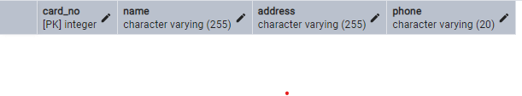

6.10
Specify the following queries in SQL on the COMPANY relational database schema shown in Figure 5.5. Show the result of each query if it is applied to the COMPANY database in Figure 5.6. You will need to create the INSERT statements to match the data in figure 5.5 (page 191 & 192)
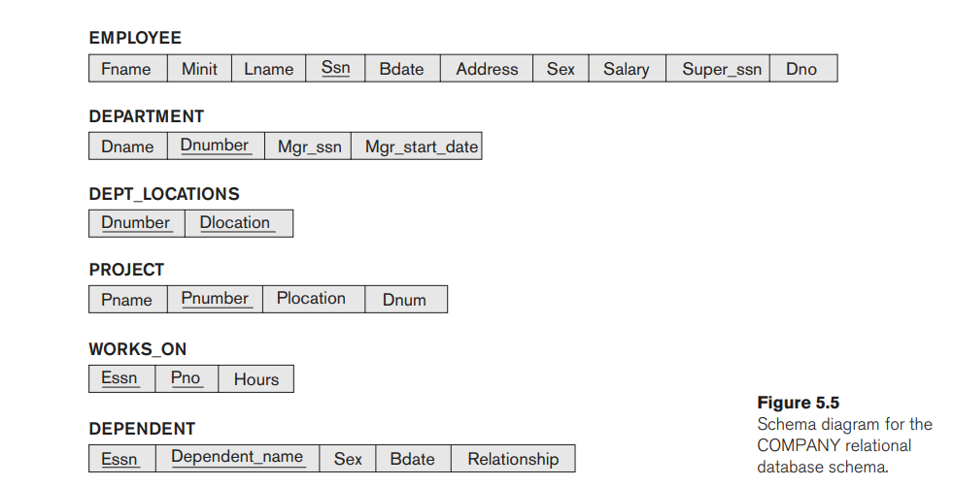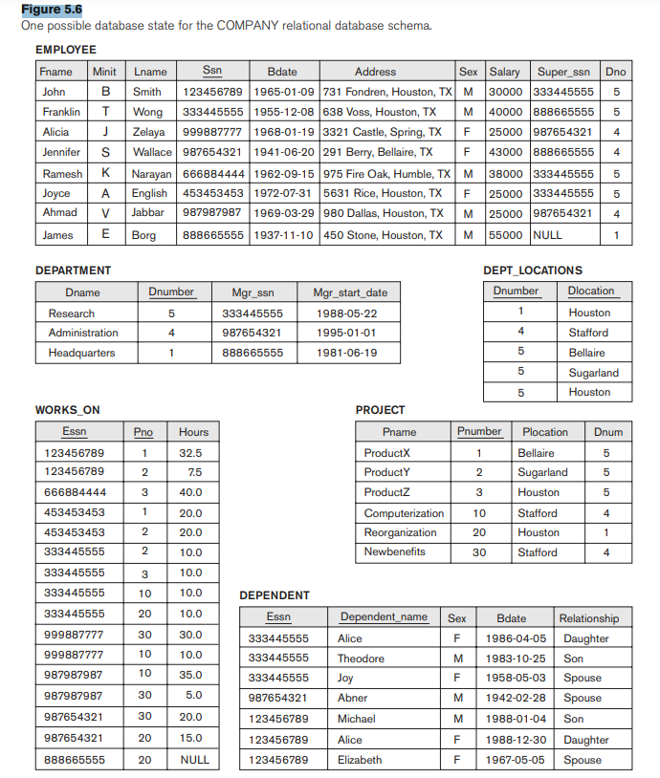

CREATE SCHEMA IF NOT EXISTS company;

CREATE TABLE IF NOT EXISTS company.Employee (
Fname TEXT,
Minit TEXT,
Lname TEXT,
Ssn VARCHAR(9) PRIMARY KEY,
Bdate DATE,
Address VARCHAR(255),
Sex CHAR(1),
Salary INT,
Super_ssn VARCHAR(9),
Dno INT
);

CREATE TABLE IF NOT EXISTS company.Department (
Dname TEXT,
Dnumber INT PRIMARY KEY,
Mgr_ssn VARCHAR(9),
Mgr_start_date DATE
);

CREATE TABLE IF NOT EXISTS company.Dept_locations (
Dnumber INT,
Dlocation TEXT,
PRIMARY KEY (Dnumber, Dlocation)
);

CREATE TABLE IF NOT EXISTS company.Project (
Pname TEXT,
Pnumber INT PRIMARY KEY,
Plocation TEXT,
Dnum INT
);

CREATE TABLE IF NOT EXISTS company.Works_on (
Essn VARCHAR(9),
Pno INT ,
Hours REAL,
PRIMARY KEY (Essn, Pno)
);

CREATE TABLE IF NOT EXISTS company.Dependent (
Essn VARCHAR(9),
Dependent_name TEXT,
Sex CHAR(1),
Bdate DATE,
Relationship TEXT,
PRIMARY KEY (Essn, Dependent_name)
);

INSERT INTO company.Employee (Fname,Minit,Lname,Ssn,Bdate,Address, Sex, Salary, Super_ssn, Dno)
VALUES ('John', 'B', 'Smith', '123456789', '1965-01-09', '731 Fondren, Houston, TX', 'M', 30000, '333445555', 5),
('Franklin', 'T', 'Wong', '333445555', '1955-12-08', '638 Voss, Houston, TX', 'M', 40000, '888665555', 5),
('Alicia', 'J', 'Zelaya', '999887777', '1968-01-19', '3321 Castle, Spring, TX', 'F', 25000, '987654321', 4),
('Jennifer', 'S', 'Wallace', '987654321', '1941-06-20', '291 Berry, Bellaire, TX', 'F', 43000, '888665555', 4),
('Ramesh', 'K', 'Narayan', '666884444', '1962-09-15', '975 Fire Oak, Humble, TX', 'M', 38000, '333445555', 5),
('Joyce', 'A', 'English', '453453453', '1972-07-31', '5631 Rice, Houston, TX', 'F', 25000, '333445555', 5),
('Ahmad', 'V', 'Jabbar', '987987987', '1959-03-29', '980 Dallas, Houston, TX', 'M', 25000, '987654321', 4),
('James', 'E', 'Borg', '888665555', '1937-11-10', '450 Stone, Houston, TX', 'M', 55000, NULL, 1);
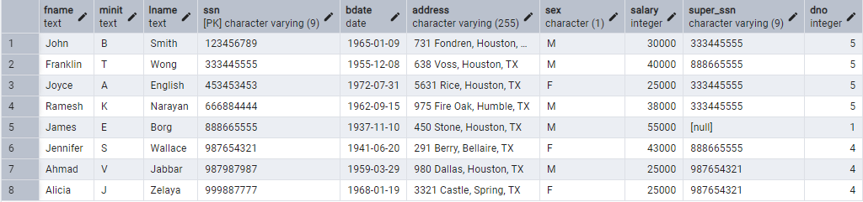

INSERT INTO company.Department (Dname, Dnumber, Mgr_ssn, Mgr_start_date)
VALUES ('Research', 5, '333445555', '1988-05-22'),
('Administration', 4, '987654321', '1995-01-01'),
('Headquarters', 1, '888665555', '1981-06-19');
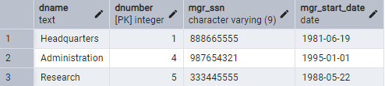

INSERT INTO company.Dept_locations (Dnumber,Dlocation)
VALUES (1, 'Houston'),
(4, 'Stafford'),
(5, 'Bellaire'),
(5, 'Sugarland'),
(5, 'Houston');
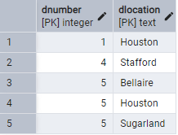

INSERT INTO company.Project (Pname, Pnumber, Plocation, Dnum)
VALUES ('ProductX', 1, 'Bellaire', 5),
('ProductY', 2, 'Sugarland', 5),
('ProductZ', 3, 'Houston', 5),
('Computerization', 10, 'Stafford', 4),
('Reorganization', 20, 'Houston', 1),
('Newbenefits', 30, 'Stafford', 4);
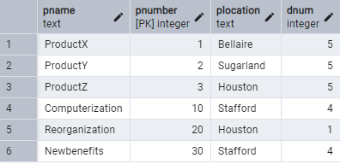

INSERT INTO company.Works_on (Essn, Pno, Hours)
VALUES ('123456789', 1, 32.5),
('123456789', 2, 7.5),
('666884444', 3, 40.0),
('453453453', 1, 20.0),
('453453453', 2, 20.0),
('333445555', 2, 10.0),
('333445555', 3, 10.0),
('333445555', 10, 10.0),
('999887777', 30, 30.0),
('999887777', 10, 10.0),
('987987987', 30, 5.0),
('987987987', 20, 15.0),
('987654321', 20, 20.0),
('987654321', 10, 15.0);
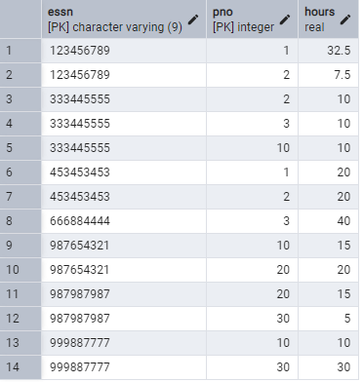
INSERT INTO company.Dependent (Essn, Dependent_name, Sex, Bdate, Relationship)
VALUES ('333445555', 'Alice', 'F', '1986-04-05', 'Daughter'),
('333445555', 'Theodore', 'M', '1983-10-25', 'Son'),
('333445555', 'Joy', 'F', '1958-05-03', 'Spouse'),
('987654321', 'Abner', 'M', '1942-02-28', 'Spouse'),
('888665555', 'Michael', 'M', '1988-01-04', 'Son'),
('888665555', 'Elizabeth', 'F', '1967-05-05', 'Spouse');
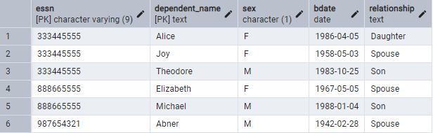

- Retrieve the names of all employees in department 5 who earns more than 3000 and works on ProductZ project.
  - SELECT e.Fname, e.Lname
  - FROM company.employee e
  - JOIN company.works_on w
  - ON e.Ssn = w.Essn
  - JOIN company.project p
  - ON w. Pno = Pnumber
  - WHERE e.Dno = 5
  - AND e.Salary > 3000
  - AND p.Pname = 'ProductZ';
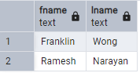
- List the names of all employees who are from Houston, Texas and works under manager 333445555.
  - SELECT e.Fname, e.Lname
  - FROM company.employee e
  - WHERE e.Address
  - LIKE '%Houston, TX%'
  - AND e.Super_ssn = '333445555';
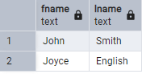
- Find the names of all employees who are working in the project Computerization.
Please submit your DDL (schema and tables), queries, and query results.
SELECT e.Fname, e.Lname
FROM company.employee e
JOIN company.works_on w
ON e.Ssn = w.Essn
JOIN company.project p
ON w.Pno = Pnumber
WHERE p.PNAME = 'Computerization';
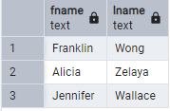

6.12 Specify the following queries in SQL on the database schema of Figure 1.2. (page 38)
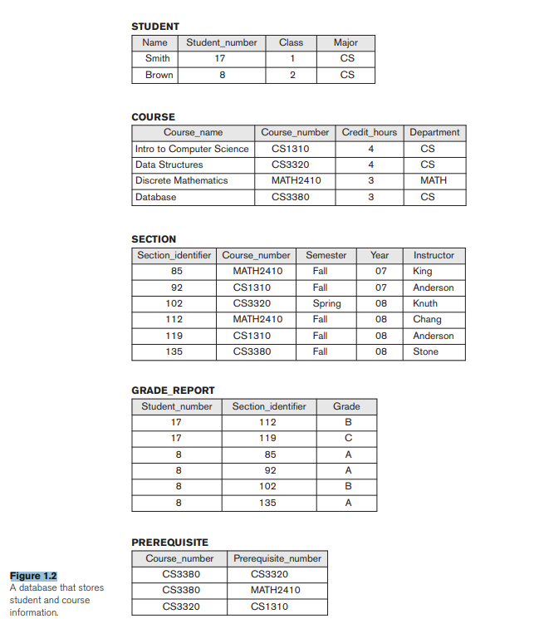

CREATE SCHEMA IF NOT EXISTS university;

CREATE TABLE IF NOT EXISTS university.Student (
Name TEXT,
Student_number INT PRIMARY KEY,
Class INT,
Major TEXT
);

CREATE TABLE IF NOT EXISTS university.Course (
Course_name TEXT,
Course_number VARCHAR PRIMARY KEY,
Credit_hours int,
Department TEXT
);

CREATE TABLE IF NOT EXISTS university.Section (
Section_identifier INT PRIMARY KEY,
Course_number VARCHAR,
Semester TEXT,
Year INT,
Instructor TEXT,
FOREIGN KEY (Course_number) REFERENCES university.Course(Course_number)
);

CREATE TABLE IF NOT EXISTS university.Grade_report (
Student_number INT,
Section_identifier INT,
Grade TEXT,
PRIMARY KEY (Student_number, Section_identifier),
FOREIGN KEY (Student_number) REFERENCES university.Student(Student_number),
FOREIGN KEY (Section_identifier) REFERENCES university.Section(Section_identifier)
);

CREATE TABLE IF NOT EXISTS university.Prerequisite (
Course_number VARCHAR,
Prerequisite_number VARCHAR,
PRIMARY KEY (Course_number, Prerequisite_number),
FOREIGN KEY (Prerequisite_number) REFERENCES university.Course(Course_number),
FOREIGN KEY (Course_number) REFERENCES university.Course(Course_number)
);

INSERT INTO university.Student (Name, Student_number, Class, Major)
VALUES ('Smith', 17, 1, 'CS'),
('Brown', 8, 2, 'CS');
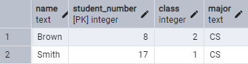

INSERT INTO university.Course (Course_name, Course_number, Credit_hours, Department)
VALUES ('Intro to Computer Science', 'CS1310', 4, 'CS'),
('Data Structures', 'CS3320', 4, 'CS'),
('Discrete Mathematics', 'MATH2410', 3, 'MATH'),
('Database', 'CS3380', 3, 'CS');

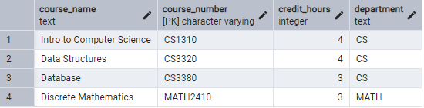

INSERT INTO university.Section (Section_identifier, Course_number, Semester, Year, Instructor)
VALUES (85, 'MATH2410', 'Fall', 2007, 'King'),
(92, 'CS1310', 'Fall', 2007, 'Anderson'),
(102, 'CS3320', 'Spring', 2008, 'Knuth'),
(112, 'MATH2410', 'Fall', 2008, 'Chang'),
(119, 'CS1310', 'Fall', 2008, 'Anderson'),
(135, 'CS3380', 'Fall', 2008, 'Stone');
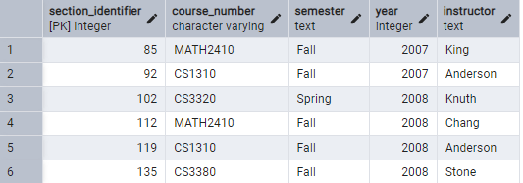

INSERT INTO university.Grade_report (Student_number, Section_identifier, Grade)
VALUES (17, 112, 'B'),
(17, 119, 'C'),
(8, 85, 'A'),
(8, 92, 'A'),
(8, 102, 'B'),
(8, 135, 'A');

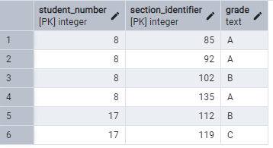

INSERT INTO university.Prerequisite (Course_number, Prerequisite_number)
VALUES ('CS3380', 'CS3320'),
('CS3380', 'MATH2410'),
('CS3320', 'CS1310');
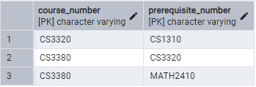
- Retrieve the course names of all the courses that comes under the department of ‘cs’ (computer science).
  - SELECT Course_name
  - FROM university.Course
  - WHERE Department = 'CS';
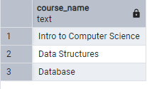
- Retrieve the names of all courses along with the name of the instructor taught during the fall of 2008.
  - SELECT c.Course_name, s.Instructor
  - FROM university.Course c
  - JOIN university.Section s
  - ON c.Course_number = s.Course_number
  - WHERE s.Semester = 'Fall' AND s.Year = 2008;
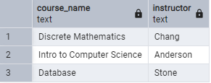
- For each section taught by Professor Anderson, retrieve the course number, semester, year, and number of students who took the section.
  - SELECT S.Course_number, s.Semester, s.Year,
  - COUNT(g.Student_number) AS number_of_students
  - FROM university.Section s
  - JOIN university.Grade_report g
  - ON s.Section_identifier = g.Section_identifier
  - WHERE s.Instructor = 'Anderson'
  - GROUP BY s.Course_number,s.Semester, s.Year;
    - 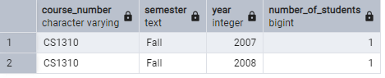
- Retrieve the name and transcript of each junior student (Class = 1) majoring in mathematics (MATH). A transcript includes course name, course number, credit hours, semester, year, and grade for each course completed by the student.
  - SELECT stu.Name, s.Semester, s.Year, g.Grade, c.Credit_hours, c.Course_name, c.Course_number
  - FROM university.Student stu
  - JOIN university.Grade_report g
  - ON stu.Student_number = g.Student_number
  - JOIN university.Section s
  - ON g.Section_identifier =s.Section_identifier
  - JOIN university.Course c
  - ON s.Course_number = c.Course_number
  - WHERE stu.Class = 1 AND STU.mAJOR = 'MATH';

You MUST WRITE THE DDL and INSERT statements to create this schema and tables. Please submit your queries AND results. The DDL is needed for the final question.

6.13
Write SQL update statements to do the following on the database schema shown in Figure 1.2.
- Insert a new course, <’Financial Accounting’, ‘fac4390’,5,’BUSINESS’>
  - INSERT INTO university.Course (Course_name, Course_number, Credit_hours, Department)
  - VALUES ('Financial Accounting', 'fac4390',5,'BUSINESS')
- Insert a new section, <145, ‘fac4390’, ‘Fall’, ‘17’, ‘Hanif’>
  - INSERT INTO university.Section (Section_identifier, Course_number, Semester, Year, Instructor)
  - VALUES (145, 'fac4390', 'Fall', 17, 'Hanif')
- Insert a new student, <’Robin’, 34, 2, ‘BUSINESS’>.
  - INSERT INTO university.Student (Name, Student_number, Class, Major)
  - VALUES ('Robin', 34, 2, 'BUSINESS')
- Update the record for the student whose student number is 17 and change his class from 1 to 3.
  - UPDATE university.STUDENT
  - SET Class = 3
  - WHERE Student_number = 17;
You only need to submit the SQL for creating the INSERT and UPDATE statements.

